Internationale Lichttage Winterthur 2004

Introduction
What is the workshop?
The sites
The Underpass
The Boiler House
The Corridor
Hall 53
Tempodrom Square
Paths Through Time
English Deutsch
Paths Through Time
Headed by Christian Vogt/ELDA
Participants: Neji Ben Ali/T, Phillip Glass/CH, Frank Langer/D, Rolf-Heinrich Breer/D, Ilka Schnelle/D, Amardeep Mohanlal Dugar/IL
The characteristic of this site is a romantic mix of three different lanes between industrial buildings of various ages.
The lanes start at small places in the middle of the old industrial area and lead along a poetical mix of industrial buildings, niches and works.
Today the lanes are generally used by pedestrians looking for one of the hidden bars or restaurants or visiting one of the small design offices or workshops. This site is full of histories that happened during the last two centuries and the living architecture offers numerous possibilities for outstanding lighting design.
Click on a thumbnail to view the full picture.
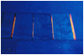 | 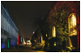 | 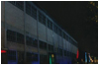 | 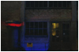 | 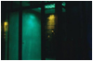
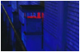 | 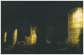 | 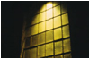 | 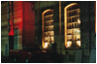 | 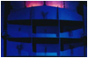
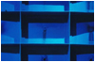 | 